##$$kk About

This is a topic in a help file.

Note how you have text formatted in the same way as in a normal word processor document.

You can have coloured text, bold, italic, large text, small text, and different fonts.

This text is written in Arial:
adsfadsfasdfasdf
It is best to use a san serif font for the body of your text as it is easier to read on screen. Arial is the most common san serif font on Windows, and is therefore a good choice.

Here is the same text written in Times New Roman (a serif font), you can see it isn’t as clear:
It is best to use a san serif font for the body of your text as it is easier to read on screen. Arial is the most common san serif font on Windows, and is therefore a good choice.

This is a link to ????

Click on me for a pop-up topic
##$$kk Files|Open|from File

Opening an allready existing file will read the settings into the Windows® interface and give a connected unit the same set of configuration.

##$$kk Files|Open|from Preset

Opening an allready existing preset will read the settings into the Windows® interface and give a connected unit the same set of configuration leave the unit in the given preset status

##$$kk Files|Save|to File as

To Save To File will load the current configuration into a file on the harddrive. The file can be read by the Windows® applications only an can be given any name.

##$$kk Files|Save|to Preset

To Save To Preset enables you to load the current configuration into the memory of the connected unit. The preset can be given a name and a date and these data will be recognized by the Windows® interface. The unit can hold 4 different configurations in its preset bank and these can be selected from the frontpanel.

##$$kk Files|Print

No help available.

##$$kk Files|Properties

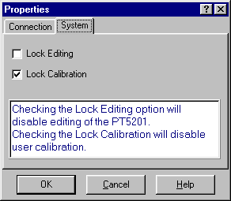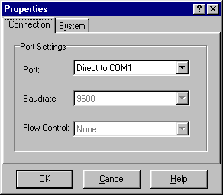

##$$kk Connect|Using|Generator Settings

The Connect Using menu opens the communication between the Windows® interface and a unit connected. The communication between the Windows® interface and the unit can be established in two modes depending on opreation. The communication can be established by the Windows® interface reading the current settings of the unit, using Connect Using/Generator Settings. To open the communication click on the desired functionally.

##$$kk Connect|Using|PC Settings

The Connect Using menu opens the communication between the Windows® interface and a unit connected. The communication between the Windows® interface and the unit can be established in two modes depending on opreation. The communication can be established by the Windows® interface writing its current/last settings, using Connect Using/PC Settings. To open the communication click on the desired functionally.

##$$kk Connect|Disconnect

Disconnect is used to abort communication between the Windows® interface and a connected unit before disconnecting the interface cable

##$$kk Connect|Demo Mode

The Demo Mode is a way to demonstrate or operate the Windows® interface off line (no PT 5201unit attached)

##$$kk Edit | Genlock

The Genlock facility enables you lock all outputs of the PT 5201, to a number of relevant video and clock sources. The outputs of PT 5201 is locked to the source in frequency and phase.

System:
System refers to the list of relevant video and clock sources PT 5201 is able to use as external reference. In PAL and NTSC burst mode PT 5201 will expect a video signal of the given system. In Internal mode all outputs of PT 5201 is locked to the internal high stability TCXO oscillator. In 10 MHz mode the source is expected to be a 10 MHz pulse train. The internal oscillator will be locked to the pulse train and PT 5201 will act as in Internal Mode. Due to the internal reference the timing feature is disabled. When the reference source is valid and the oscillator circuit is in lock, the ”Genlocked” LED on the front panel, will be lit.

Timing:
All outputs of PT 5201 is timable with reference to the Genlock video signal. All output is timed in parallel in resolution of the individuel output.

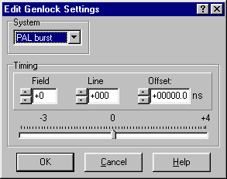##$$kk Edit | BB

All tree Black Burst outputs are digitaly generated under the VariTimeTM system and are independ in timing and generation of TVsystem (NTSC/PAL).

Black Burst 1: Black Burst 1 (BB1) is digitaly generated under the VariTimeTM system and is independ in timing and generation of TVsystem (NTSC/PAL). The VariTimeTM system has a resolution of 0.15 ns and the timing range of 4 fields for NTSC and 8 fields for PAL.
System: The VariTimeTM outputs are able to generate Black Burst in both TVsystems, NTSC and PAL.
Timing: The VariTimeTM outputs are generating Black Burst with a resolution of 0.15 ns and the timing range of 4 fields for NTSC and 8 fields for PAL.
Field, Line,
Offset: The VariTimeTM outputs are generating Black Burst with a resolution of 0.15 ns and the timing range of 4 fields for NTSC and 8 fields for PAL. Edit of the number of Fields, Lines or Offset of ns to be advanced or disadvanced can be done in tree ways. The modification are typed dirrectly in the edit boxes using number keys and sign, incremented or decremented up and down by the arrow buttons or using the timing bar. The timing bar are used by grapping the pointer with the mouse and moving it, for quick timing.
ScH-Phase: The VariTimeTM system features adjustment of the ScH-Phase in the range of 3 180º in a resolution of 1º, operated using the arrow buttons, up and down or typed directly in.

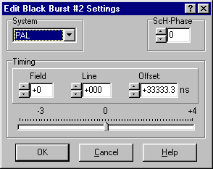

##$$kk Edit | TSG

The Test Signal Generator contains 23 basic patterns and signals, including Color Bars for the respective TVsystems. The TSG outputs signals in two formats simultaneously, Analog Composite (TSG output) and SDI (SDI output) and has a common of 4 or 8 fields timing range in 37 ns resolution. The SDI output features separate settings for embedded audio. The Analog Composite output features ScH-Phase adjustment in 1º resolution.
System: The TSG and SDI output generates patterns in both NTSC/525 lines and PAL/625 lines systems. One common system for both output at a time.
Timing: The VariTimeTM outputs are generating Black Burst with a resolution of 37 ns and the timing range of 4 fields for NTSC and 8 fields for PAL.
Field, Line,
Offset: The VariTimeTM outputs are generating Black Burst with a resolution of 37 ns and the timing range of 4 fields for NTSC and 8 fields for PAL. Edit of the number of Fields, Lines or Offset of ns to be advanced or disadvanced can be done in tree ways. The modification are typed dirrectly in the edit boxes using number keys and sign, incremented or decremented up and down by the arrow buttons or using the timing bar. The timing bar are used by grapping the pointer with the mouse and moving it, for quick timing.
ScH-Phase: The TSG features adjustment of the ScH-Phase in the range of 3 180º in a resolution of 1º, operated using the arrow buttons, up and down or typed directly in.

Pattern: The Test Signal Generator contains 23 basic patterns and signals, including Color Bars for the respective TVsystems. The list of signals consist of 19 patterns for NTSC and 21 patterns for PAL. The TSG outputs signals in two formats simultaneously, Analog Composite (TSG output) and SDI (SDI output).
Analog
Settings: The Analog Composite output features common timing and ScH-Phase adjustment in 1º resolution.
SDI
Settings: The SDI output features common timing and separate settings for embedded audio.
ScH-Phase: The Analog Composite output features adjustment of the ScH-Phase in the range of 3 180º in a resolution of 1º.

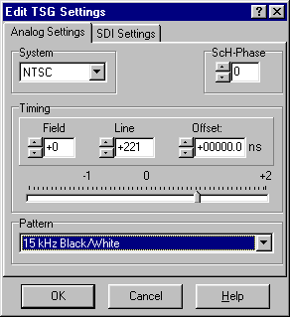

##$$kk Edit | Audio

Audio: PT 5201 contains two independent audio generators, Analog Audio and AES/EBU digital audio and a WordClock output (WCLK). Due to common rear connector, only one audio generator can be active at a time. The AES/EBU generator features selectable sample rate, video reference lock, timing and a number of tones and levels. The Analog Audio generator features four tones in a large number of levels and right channel identification.

System: In Genlocked mode the AES/EBU generator locks to both video systems and in Internal mode the audio generator is locked to the internal reference.

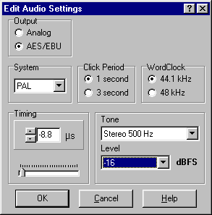##$$kk Edit|System

The System menu enables you to calibrate the main oscillator using this Windows® interface and fix all video output to the same TVsystem (NTSC/PAL), during a Factory Reset. Performing a Factory Reset replace all current settings with the settings the unit has from factory and will not affect any of the four user presets.
Factory
Reset: Factory Reset replace all current settings with the settings the unit has from factory. In Edit/System/Factory Reset the user is able to select to wich TV system (NTSC, 525/PAL, 625) all Video output will generate, performing a Reset.
The factory settings is, internal reference, no timing advancement of Video outputs, AES/EBU Audio at 48 KHz. Note that Factory Reset will not affect any of the four user presets.

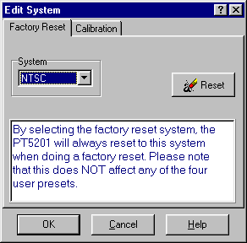

Calibration: The calibration menu enables you to calibrate the unit without taking it out of a rack and out of service. The unit is calibrated using this Windows® interface and a general purpose counter connected to the BB1 terminal. This calibration will effect the frequency of the main oscillator only, no other circuits needs frequent calibration. To secure the factory calibration the unit is secured with a calibration lock function. To unlock and lock the calibration mode you enter Files/Properties/System.

Calibration procedure:
1) Turn on the unit and connect it to a PC running the Windows® interface
2) Connect a general purpose counter to BB1 output
3) Unlock the calibration mode in Files/Properties/System and enter the calibration menu at Edit/System/Calibration
4) Click on Unlock and expect a TTL clock at 4.5 MHz on the BB1 connector. There is now acces to calibrate the main oscillator and using the arrow buttons, up or down, the calibration is final when the BB1 outputs 4,500,000 Hz.
5) The calibration is stored in the unit by clicking on Save. By clicking on Cancel at any time before clicking on Save, the caibration mode will be terminated and the unit will hold the present calibration.

Note: Make sure to lock the calibration mode in Files/Properties/System to ensure no calibration is made by mistake.

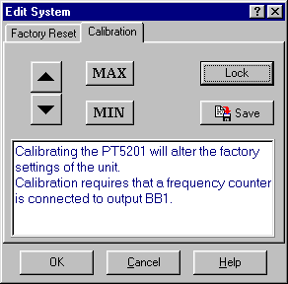
##$$kk View|System Status

The System Status window will expand the Front Panel window and provide a veiw of settings of all outputs. Besides information on timing, pattern and audio types and tones, the System Status gives information on unit serial nr., SW release, Preset Status and serial communication (SCPI) status. Edditing of the settings are accesseble by dubble click on each generator. By dubble click on a generator the generator window opens and editing is possible.
The System Status window is not default and opens by checking System Status in Veiw/System Status

##$$kk View|Status Bar

Status Bar: The Status Bar is default and is shown below the Front Panel or System Status window. This bar provides information on communications from the Windows® interface to the connected unit. The Status Bar states if a n unit is present or not (connected/disconnected), wich COM port are selected and the baud rate. Allso it states if the Windows® interface is used in Demo Mode.

##$$kk Help
##$$kk Pop-up Topic

Pop-up topics allow you to give definitions of words, or brief explanations while keeping a normal topic open.

# IDH_ABOUT
$ About
k About
# IDH_FILESOPENFILE
$ Files
k Open from File
# IDH_FILESOPENPRESET
$ Files
k Open from Preset
# IDH_FILESSAVEFILE
$ Topic 4
k Save to File
# IDH_FILESSAVEPRESET
$ Topic 5
k Save to Preset
# IDH_FILESPRINT
$ Topic 6
k Print
# IDH_FILESPROPERTIES
$ Topic 7
k File properties
# IDH_CONNECTGENERATORSETTINGS
$ Connect Using Generator Settings
k Connect;Generator;Settings
# IDH_CONNECTPCSETTINGS
$ Connect Using PC Settings
k Connect;PC Settings
# IDH_CONNECTDISCONNECT
$ Connect
k Connect;Disconnect
# IDH_CONNECTDEMOMODE
$ Topic 11
k topic 11
# IDH_EDITGENLOCK
$ Topic 12
k Genlock Settings
# IDH_EDITBB
$ Topic 13
k BB settings
# IDH_EDITTSG
$ Topic 14
k TSG settings
# IDH_EDITAUDIO
$ Topic 15
k Audio Settings
# IDH_EDITSYSTEM
$ Topic 16
k topic 16
# IDH_VIEWSYSTEMSTATUS
$ Topic 17
k topic 17
# IDH_VIEWSTATUSBAR
$ Topic 18
k topic 18
# IDH_HELP
$ Topic 19
k topic 19
# IDH_TOPIC20
$ Topic 20
k topic 20; pop-up

